AIR BOSS 101
Introductory Course for Initial LOA Eligibility

STUDENT WORKBOOK
ABRP Manual Rev 2.0 | May 2026
OpsNormal Airboss · opsnormalairboss.com
Candidate name: ____________________________________________
Date: _______________________ Instructor: ________________
Course location: ___________________________________________
This workbook is for use during Air Boss 101 instruction only.
It is not a substitute for the ABRP Manual, FAA Order 8900.1, or the issued Certificate of Waiver.

HOW TO USE THIS WORKBOOK
This workbook accompanies the Air Boss 101 classroom presentation. It is organized to match the six course modules and two appendices. Use it to:
- Record key points and personal notes during each module.
- Work through scenario exercises during group discussion.
- Complete module knowledge checks after each section.
- Review key terms and the BAB scope summary before the examination.

EXAMINATION
The Air Boss 101 Knowledge Examination consists of 15 multiple-choice questions with a minimum passing score of 80% (12 of 15 correct), per ABRP Manual §11. The exam is closed-book. The module knowledge checks in this workbook are not exam questions — they are discussion exercises to reinforce understanding.

LOA PATHWAY
Successful completion of Air Boss 101, plus three Show Day Credits and an Evaluative Conference with an ABI or ABE, qualifies a candidate to apply for the Basic Air Boss (BAB) Letter of Authorization under ABRP Manual §3(b) and §11(a)(i).

COURSE OVERVIEW
Learning Outcomes
Upon completing Air Boss 101, you will be able to:
1. State the ICAS Safety Creed and explain its operational meaning for every show-day decision.
2. Define Basic Air Show and identify all 11 BAB operational limitations by name and source.
3. Explain FAA authority, FAA Order 8900.1, and the Certificate of Waiver / Certificate of Authorization framework.
4. Describe the Air Boss role, authority boundaries, and chain of command at an air show.
5. Identify all required elements of a Participants Safety Briefing under FAA Order 8900.1.
6. Plan and execute pre-show and show-day Air Boss duties at a Basic Air Show.
7. Apply hazard identification and risk mitigation principles to real show-day scenarios.
8. Demonstrate the knowledge required to enter an Evaluative Conference for the BAB LOA.
BAB Scope — What This Course Covers
Basic Air Shows: ≤5 Aerial Acts / Show Day · Daytime only · ≤1 act airborne at a time
COW / COA review · TFR awareness · ASDA / FDA definitions
Crowd line categories and separation distances at Basic Show level
Participants Safety Briefing — all required FAA Order elements
Stop-the-Show authority and execution
Airborne pyrotechnics (ACE endorsement required) · Parachute ops (no circle-jumper)
ERP and IAP — the Air Boss role in emergency planning

Topics requiring SAB or higher (not covered in this course): night operations, sanctioned military jet demo team management, circle-the-jumper, ground-based pyrotechnics, Cat I aerobatics, complex multi-venue operations.
MY QUESTIONS BEFORE WE BEGIN

MODULE 1 — WHAT IS AN AIR SHOW?
Slides 5–10 · Foundational definitions and context
1.1 The Air Show Environment
An air show is a public event featuring scheduled aerial demonstrations, conducted under an FAA Certificate of Waiver. What makes air shows unique is the simultaneous presence of performing aircraft, spectators, and active airport operations in the same environment.
STAKEHOLDER MAP — FILL IN THE PRIMARY RESPONSIBILITY FOR EACH ROLE
Role | Primary Responsibility at an Air Show
Event Organizer / Responsible Person
FAA Inspector-in-Charge (IIC)
Airport Manager / Airport Operations
ARFF / EMS
Air Boss

1.2 ABRP Credential Levels
BAB — Basic Air Boss: Basic Air Shows only (this course)
SAB — Standard Air Boss: Standard Air Shows and below
RAB/SV — Recognized Air Boss / Single Venue: specific venue authorization
RAB/MV — Recognized Air Boss / Multiple Venue: multiple venue authorization

Support roles: ABI (Air Boss Instructor) · ABE (Air Boss Evaluator)
NOTES — WHY CREDENTIAL SCOPE MUST MATCH SHOW COMPLEXITY

1.3 Basic Air Show — Definition and Limitations
THE 11 BAB LIMITATIONS (ABRP MANUAL, SECTION 1) — CHECK EACH AS COVERED IN THE BRIEFING
☐ ≤5 Aerial Acts per Show Day
☐ Daytime operations ONLY — no performances after civil twilight
☐ ≤1 Aerial Act airborne at a time (one additional may hold outside Aerobatic Box if briefed)
☐ No circle-the-jumper operations
☐ No sanctioned military demo teams (Blue Angels, Thunderbirds, Snowbirds)
☐ No ground or water vehicle vs. aircraft races
☐ No Non-Participating Aircraft within the ASDA during performance
☐ No ground-based pyrotechnic displays
☐ Airborne pyrotechnics: ONLY if pilot holds an ACE endorsement
☐ No Cat I aircraft aerobatics (non-aerobatic Cat I fly-bys are permitted)
☐ No Cat I aircraft aerobatic management (SAB or higher required)
1.4–1.5 ICAS Safety Creed & Code of Ethics
THE FIVE COMMITMENTS — COMPLETE EACH IN YOUR OWN WORDS
Safety of audiences, performers, and the general public is…

We will not violate ICAS safety standards because…

We will not promote or condone unsafe acts because…

Our individual actions reflect on…

We hold ourselves to the highest safety standards by…

SCENARIO 1
A major sponsor calls the event director the morning of the show and threatens to pull funding unless a Cat I aerobatic act — not in the COW — is added. The event director asks the Air Boss to 'figure something out.' You are the Air Boss.
What is your authority in this situation?

What does the ICAS Safety Creed require of you?

MODULE KNOWLEDGE CHECK
1. A Basic Air Show may have a maximum of how many Aerial Acts per Show Day?
A) 3
B) 5
C) 10
D) No limit, provided they do not overlap
2. Which document specifically governs how Aviation Safety Inspectors manage air shows?
A) ABRP Manual Rev 2.0
B) FAA Order 8900.1
C) AC 91-45C
D) FAR Part 91
3. Circle-the-jumper parachute operations at a Basic Air Show are:
A) Permitted if the jump master holds an ACE endorsement
B) Permitted with IIC approval
C) Not authorized — SAB or higher required
D) Permitted at the Air Boss's discretion
ANSWER KEY: DISCUSS WITH INSTRUCTOR

MODULE 2 — FAA REGULATORY FRAMEWORK
Slides 11–24 · Authority, documents, and airspace
2.1 Governing Regulations and Orders
DOCUMENT HIERARCHY — MATCH EACH DOCUMENT TO ITS FUNCTION
Document | Function / What the Air Boss Must Know
FAA Order 8900.1
Federal Aviation Regulations (FARs)
FSDO
FAA Inspector-in-Charge (IIC)

2.2–2.3 Certificate of Waiver / Authorization and TFR
COW (Certificate of Waiver): FAA document waiving specific FARs for the event
COA (Certificate of Authorization): issued for controlled airspace / UAS operations
FAA Form 7711-2: the application form — errors on the form produce errors on the issued document
TFR (Temporary Flight Restriction): NOTAM-based protection of the ASDA from non-participating aircraft
COW REVIEW CHECKLIST — ITEMS TO VERIFY BEFORE ASSUMING SHOW DUTIES
☐ Dates and effective times are correct
☐ Geographic coordinates match the site
☐ All waived FARs are listed and understood
☐ FARs NOT waived are identified
☐ Authorized act categories and separation distances
☐ Performer-specific restrictions or endorsements required
☐ Emergency plan references and required attachments
TFR — COMMON ERRORS
The most common TFR reading error: a candidate reads only the first line of the NOTAM and believes the restriction is continuous, when the actual effective times appear in a 'daily HH:00–HH:00' clause buried mid-document. What is your procedure when you find a discrepancy between the COW and the published TFR?

2.4–2.5 ASDA, FDA, and Crowd Line
DEFINITIONS — WRITE THE FULL DEFINITION FOR EACH TERM
ASDA (Air Show Demonstration Area):

FDA / Aerobatic Box:

Show Center:

Show Line:

Cat I / Cat II / Cat III:

2.6–2.8 Airspace Conflicts, FSDO, and ATC Coordination
NOTES — INCURSION RESPONSE PROCEDURE (WHO YOU CALL, IN WHAT ORDER, WHAT YOU TRANSMIT)

SCENARIO 2
During your pre-show TFR review, you discover the TFR altitudes in the NOTAM do not match the altitudes specified in the issued COW. The show is scheduled to start in four hours.
What do you do, and in what order?

What authority can officially resolve the discrepancy?

MODULE KNOWLEDGE CHECK
1. Which FAA office issues the Certificate of Waiver for an aviation event?
A) AFS-830, the National Field Office for Aviation Events
B) The Flight Standards District Office (FSDO)
C) The Air Route Traffic Control Center (ARTCC)
D) The FAA Administrator's office
2. When a non-participating aircraft enters the ASDA during performance, the Air Boss's immediate action is to:
A) Contact the FSDO
B) Transmit 'Knock It Off' on the Air Boss frequency and notify ATC and the IIC
C) Wait for ATC to resolve the conflict
D) Notify the event director
3. The Air Boss sightline to the full Flying Display Area must be:
A) Verified once before the first Show Day
B) Maintained without obstruction at all times during performance
C) Maintained only during aerobatic acts
D) Documented in the ERP
ANSWER KEY: DISCUSS WITH INSTRUCTOR

MODULE 3 — ROLE & AUTHORITY OF THE AIR BOSS
Slides 25–32 · Who the Air Boss is and what the job requires
3.1 The Air Boss Defined
A certificated individual holding an FAA Letter of Authorization (LOA) to manage aerial activity at air shows.
The single authority for all airspace decisions during performance.
Authority flows from the COW and FAA Order 8900.1 — not from title or experience alone.
AUTHORITY BOUNDARIES — MARK EACH STATEMENT TRUE OR FALSE AND EXPLAIN
TRUE / FALSE The Air Boss may override the IIC's decision to suspend the COW.

TRUE / FALSE The Air Boss has authority over all Participating Aircraft within the ASDA during performance.

TRUE / FALSE The Air Boss may direct ATC to clear non-participating aircraft from off-COW airspace.

TRUE / FALSE The Air Boss may deny a performer's request to add an unscheduled maneuver during the show.

TRUE / FALSE The Air Boss's authority ends when the COW-defined airspace boundary is crossed.

3.2 Key Personnel and Chain of Command
CHAIN OF COMMAND MATRIX — FILL IN EACH CELL
Role | Authority Over | Defers to Air Boss On
Responsible Person (RP)
FAA IIC
Airport Manager
Incident Commander (IC)
ATC

3.3–3.4 Primary Air Boss, Competencies, and Aircraft Categories
NOTES — SITUATIONAL AWARENESS: WHAT THE AIR BOSS MUST TRACK SIMULTANEOUSLY DURING PERFORMANCE

3.5 BAB LOA Requirements
Initial BAB Requirements (ABRP Manual, §3): 18 years · English proficiency
Air Boss 101 within 24 months · 3 Show Day Credits within 24 months
Evaluative Conference with an ABI or ABE

Renewal: Air Boss 102 · 9 Show Day Credits · Evaluative Conference
LOA Validity: through December 31 of the third full calendar year after issuance year
SCENARIO 3
You are shadowing an Air Boss at a Basic Air Show. Mid-show, the Air Boss steps away from the position for five minutes. No qualified replacement has been designated. An act is airborne in the FDA.
What should have been arranged before the Air Boss stepped away?

As the Shadow candidate, what do you do in this situation?

MODULE KNOWLEDGE CHECK
1. The Air Boss's authority is derived from:
A) Years of flight experience
B) The Certificate of Waiver and FAA Order 8900.1
C) ICAS membership
D) The event director's designation
2. When multiple qualified Air Bosses are present at an event, who holds final aerial safety authority?
A) The most senior by credential level
B) The designated Primary Air Boss
C) The one with the most Show Day Credits
D) The one designated by the IIC
3. An initial BAB LOA requires completion of Air Boss 101 within how many months of the application?
A) 12 months
B) 18 months
C) 24 months
D) 36 months
ANSWER KEY: DISCUSS WITH INSTRUCTOR

MODULE 4 — CORE DUTIES: PRE-SHOW
Slides 33–43 · Pre-event coordination and preparation
4.1 Site Assessment
SITE WALK CHECKLIST — COMPLETE BEFORE THE FIRST AIRCRAFT MOVES
☐ Runway dimensions, displaced thresholds, and known obstructions verified
☐ Show center sightline confirmed — Air Boss can see the full FDA without obstruction
☐ Crowd line markers placed per COW specifications and separation distances verified
☐ Emergency vehicle access routes identified and confirmed unobstructed
☐ Emergency vehicle staging positions confirmed — do not conflict with crowd line
☐ Show center, show line, and performer hold areas confirmed and marked
☐ Non-airport venue considerations addressed (terrain, population density, emergency services)
4.2–4.3 Reviewing Documents and the Show Schedule
NOTES — WHAT I MUST VERIFY IN THE COW BEFORE ASSUMING SHOW DUTIES

SHOW SCHEDULE REQUIRED ELEMENTS
☐ On-stage times for each act (specific, not approximate ranges)
☐ Duration for each act
☐ Special instructions: air starts, formation builds, hold sequences
☐ Performer identifier for each slot (aircraft type and/or call sign)
☐ Distributed to: FAA/IIC, ARFF, ATC, narrators, performers, event director
4.4–4.5 Performer Coordination and Communications Planning
PERFORMER HANDOUT — REQUIRED CONTENTS
☐ Airspace diagram and airport layout
☐ All frequencies (Air Boss primary, backup, discrete, narrator/PA)
☐ FBO location, fuel procedures, smoke system location
☐ Aerial photography / Google Earth image of the site
☐ All NOTAMs and special local procedures
☐ Alternate airports, divert fields, and ERP communications net
LOSS-OF-COMMUNICATIONS PLAN — WRITE THE KEY ELEMENTS OF YOUR PLAN
FAA Order 8900.1 requires a briefed loss-of-communications procedure. Each performer must know exactly what to do if they cannot hear the Air Boss.

4.6–4.7 Airport, ATC, and Emergency Planning
ERP VS. IAP — EXPLAIN THE DIFFERENCE
ERP (Emergency Response Plan): ____________________________________________________
___________________________________________________________________________________

IAP (Incident Action Plan): _______________________________________________________
___________________________________________________________________________________
PRE-SHOW EMERGENCY DRILL — REQUIRED ELEMENTS TO VERIFY
☐ Communications check: all parties on designated frequencies
☐ Incident notification sequence: Air Boss KIO — IIC notification — ARFF staging
☐ Access route: physically walk/drive emergency access routes
☐ Landing zone: EMS helicopter LZ is clear, marked, and accessible
☐ Mutual aid triggers: who calls for mutual aid and under what condition
☐ Drill logged: date, time, participants, deficiencies, resolution
4.8 Weather Assessment
Weather data currency: within 45 minutes of brief start
Sources: ATIS · METARs · TAFs · PIREPs · Winds aloft (3k / 6k / 9k / 12k ft MSL)
Go/No-Go authority: Air Boss and IIC jointly — Air Boss recommends; show director may cancel
Know the thresholds for: delay · low-show modification · suspension / termination
SCENARIO 4
It is 0630, one hour before the morning brief. The METAR shows 1,200-foot ceilings and 3 miles visibility. The COW minimum for Cat II acts is 1,500 feet and 3 miles. The event director tells you the crowd is already arriving and asks you to 'see what you can do.'
What is the current go/no-go status for Cat II acts?

What do you communicate to the event director and what monitoring plan do you establish?

MODULE KNOWLEDGE CHECK
1. The show schedule submitted with the COW application is:
A) A suggestion — the Air Boss may adjust it freely on show day
B) Part of the regulatory record — deviations require IIC notification
C) Owned by the event director, not the Air Boss
D) Only relevant if the IIC requests it
2. An emergency drill before the first Show Day is:
A) Required by FAA Order 8900.1
B) Recommended but waivable for time
C) Only required at shows with more than three acts
D) The event director's responsibility, not the Air Boss's
3. Standby aircraft for an emergency must:
A) Be the same aircraft used in the flying display to save time
B) NOT be any aircraft in the flying display
C) Be a Cat I aircraft
D) Be positioned inside the ASDA during the show
ANSWER KEY: DISCUSS WITH INSTRUCTOR

MODULE 5 — CORE DUTIES: SHOW DAY
Slides 44–58 · Operational responsibilities from briefing to debrief
5.1 The Participants Safety Briefing
A Participants Safety Briefing MUST be conducted before every Show Day (FAA Order 8900.1). It is not optional and every required element must be addressed.
REQUIRED BRIEFING ELEMENTS — CHECK EACH WHEN COVERED
☐ Introductions: Air Boss, event director, narrators, IIC, airport operations representative
☐ Time hack: all watches and clocks synchronized
☐ Altimeter setting and 14 CFR 91.121 waiver (if applicable)
☐ ASDA boundaries, FDA location and dimensions
☐ TFR boundaries, altitudes, and effective times
☐ NOTAMs — reviewed aloud
☐ Show center, show line, crowd line, Cat I/II/III positions
☐ Alternate airports and divert fields
☐ Current METAR: ceiling, visibility, winds
☐ Winds aloft at 3,000 / 6,000 / 9,000 / 12,000 ft MSL
☐ TAF trend and trigger conditions for delay or low-show
☐ Schedule walkthrough — every slot, with all involved performers
☐ Primary Air Boss frequency and backup frequency
☐ Discrete frequencies for individual acts
☐ Transponder codes (default 1200; specific squawk codes if required)
☐ Loss-of-communications procedure
☐ KIO visual signal — briefed and confirmed with all performers
☐ IIC authority on-airport — only IIC and fire department enter incident area
☐ Emergency frequency and communications net from the ERP
☐ Divert field and alternate runway procedures
☐ IMSAFE self-certification — all performers
☐ G-LOC awareness and AGSM reminder for aerobatic performers
☐ Smoke system procedures and de-confliction
☐ Airborne pyrotechnics: ACE endorsement verified, KIO altitude, de-confliction
☐ Specialty briefings after main brief: ribbon cuts, formations, parachute operations
BRIEFING DELIVERY — PERSONAL REMINDERS FOR EFFECTIVE AUTHORITY

5.2 Pre-Performance Checks
☐ Radio frequency integrity test: transmit on each frequency and confirm acknowledgment
☐ Narrators confirmed on correct frequency — NOT on Air Boss frequency
☐ IIC contact established on emergency net
☐ ATC confirmed aware that TFR / COW window is active
☐ Crowd line marked, crowd behind line, line clear
☐ Emergency vehicles in pre-briefed staging positions
☐ Emergency access routes unobstructed
☐ IIC in position and confirmed on-net
☐ FDA / Aerobatic Box positively confirmed clear before any act authorized
☐ All Participating Aircraft accounted for — location known for each
☐ ACE endorsements verified for all applicable acts
5.3 Managing the Performance Window
Standard release call: '[Call sign], [Air Boss], clear to perform'
Positive FDA clearance required before each act entry — not assumed, confirmed
One-act-at-a-time rule: ≤1 Aerial Act airborne in the FDA at any time
Track status of every aircraft at all times: airborne / holding / on ground
Monitor simultaneously: show timing vs. sunset, TFR expiration, weather, fuel
5.4–5.5 Ground Activity, Safety Alerts, and Non-Radio Communications
NON-RADIO VISUAL SIGNALS — FILL IN THE MEANING OF EACH SIGNAL
Thumbs up: Means: ___________________________________________
Crossed arms overhead: Means: ___________________________________________
Wave both arms overhead: Means: ___________________________________________
Point to ears, then headset: Means: ___________________________________________
5.5 Stop-the-Show Authority
WHEN TO STOP THE SHOW — LIST EVERY TRIGGER YOU CAN RECALL

STOP-THE-SHOW IS NOT FAILURE. It is the primary safety tool available to the Air Boss.
Radio call: 'Knock It Off, Knock It Off' on Air Boss frequency.
Resuming: conditions must be resolved and FDA positively re-cleared before any act enters.
5.6–5.8 Aircraft Emergency, Loss of Life, and Post-Performance
NOTES — AIR BOSS IMMEDIATE ACTIONS DURING AN AIRCRAFT EMERGENCY

Key distinction: the Air Boss coordinates airspace; the IIC commands the ground response. The Air Boss does NOT enter the incident area.
NOTES — END-OF-SHOW CHECKLIST (AIRSPACE CLOSURE, IIC DEBRIEF, TFR RELEASE)

SCENARIO 5
During performance, your narration team's frequency bleeds over onto the Air Boss frequency. Performers begin asking you to repeat transmissions. The next act is in the hold area, ready to enter the FDA.
What is your immediate action regarding the next act?

How do you resolve the frequency conflict without interrupting airspace management?

SCENARIO 6
A performer completes an act and does not respond to your FDA clearance call for 30 seconds. A second performer is taxiing to the hold area.
What is your priority?

At what point does this situation become a stop-the-show condition?

MODULE KNOWLEDGE CHECK
1. A Participants Safety Briefing may be conducted by phone for off-site performers when:
A) The IIC approves the waiver in writing
B) The event director authorizes it
C) FAA must be notified and all required elements are covered
D) The performer has attended a previous show at the same venue
2. Non-radio visual communication signals must be:
A) Improvised as needed on show day
B) Briefed at the Participants Safety Briefing and confirmed before performance
C) Only used by the Air Boss — not performers
D) Documented in the COW
3. After a stop-the-show, the FDA may be re-opened when:
A) The IIC authorizes it
B) Five minutes have elapsed
C) Conditions are resolved and the FDA is positively re-cleared
D) The event director confirms it is safe to resume
ANSWER KEY: DISCUSS WITH INSTRUCTOR

MODULE 6 — SAFETY & RISK MANAGEMENT
Slides 59–69 · Foundations, human factors, and evaluation readiness
6.1–6.2 Hazard Identification and Risk Mitigation Hierarchy
THE RISK MITIGATION HIERARCHY — FILL IN EACH LEVEL AND GIVE AN AIR SHOW EXAMPLE
Level | Control Type | Air Show Example
1 — Elimination
2 — Substitution
3 — Engineering Controls
4 — Administrative Controls
5 — PPE

PRE-SHOW HAZARD REVIEW — IDENTIFY THE HAZARD CATEGORY FOR EACH ITEM
• Performers have not flown this site before Category: _______________
• TFR altitudes differ from COW by 500 ft Category: _______________
• Trees 40 ft tall at the east end of the runway Category: _______________
• A performer deviated from their profile at last show Category: _______________
• Emergency access road blocked by sponsor trucks Category: _______________
6.3 Human Factors — IMSAFE
IMSAFE — WRITE WHAT EACH LETTER STANDS FOR AND ITS AIR SHOW IMPLICATION
I — _________________________________________________________________
M — _________________________________________________________________
S — _________________________________________________________________
A — _________________________________________________________________
F — _________________________________________________________________
E — _________________________________________________________________

G-LOC AND CRM — KEY POINTS

6.4 Stop-the-Show as a Safety Competency
The threshold for stopping should be LOWER than the threshold for accepting risk.
Competent Air Bosses stop early — when conditions first become uncertain.
ABRP and FAA support an Air Boss who stops a show for safety.
Document every stop: what you observed, the trigger, the decision, what happened.
NOTES — STOP-THE-SHOW TRIGGERS I WILL PRE-BRIEF TO PERFORMERS

6.5–6.6 Pyrotechnics and Parachute Operations
Airborne pyrotechnics: PERMITTED with ACE endorsement — verify before authorizing the act
Ground pyrotechnics: NOT PERMITTED at Basic Air Shows — any request must be declined
Parachute operations: PERMITTED — circle-the-jumper is NOT permitted
Jump aircraft counts as the active act — no other aircraft may enter the FDA while jumpers are airborne
6.7–6.8 Post-Show Responsibilities and Evaluation Readiness
POST-SHOW DEBRIEF CHECKLIST
☐ Review what went as briefed and what deviated — with performers
☐ Discuss communications problems, schedule conflicts, airspace issues
☐ Written record of all deviations from the briefed program
☐ Written record of all incidents, near-misses, or significant events
☐ Reporting obligations confirmed — know the FAA Order 8900.1 threshold
☐ Identify hazards to address before the next Show Day
☐ IIC debriefed before departure
☐ TFR / ASDA released to ATC and regular operations confirmed
EVALUATIVE CONFERENCE — WHAT THE ABE WILL ASSESS
Planning: COW review, schedule, emergency planning, site assessment
Briefing: all required FAA Order elements, delivery quality, completeness
Air/Ground Operations: FDA management, one-act-at-a-time, stop-the-show, communications
Other Issues: professionalism, Safety Creed alignment, documentation

Bold items in the ABRP Evaluation Report are REQUIRED — failure on any required item fails the evaluation.
SCENARIO 7
After a two-Show-Day event, a performer tells you privately that another performer was flying noticeably below the briefed altitude minimums on the second day. You did not observe this directly from the Air Boss position.
What are your documentation and reporting obligations?

What does the ABRP Code of Ethics require of you?

MODULE KNOWLEDGE CHECK
1. The first step in the risk mitigation hierarchy is:
A) Engineering controls such as physical barriers
B) Administrative controls such as re-briefing
C) Elimination — remove the hazard entirely
D) Substitution with a lower-risk alternative
2. Airborne pyrotechnics at a Basic Air Show require:
A) IIC approval for each act
B) The pilot to hold an ACE endorsement, verified before authorizing the act
C) Written approval from ICAS
D) A ground pyro crew on standby
3. The IMSAFE checklist applies to:
A) Performers only
B) Ground crew only
C) Performers and the Air Boss
D) The event director
ANSWER KEY: DISCUSS WITH INSTRUCTOR

APPENDIX A — KEY TERMS QUICK REFERENCE
Use this section to record definitions in your own words during the course.
Term | Definition
ABRP | Air Boss Recognition Program — the ICAS program that administers Air Boss credentials and LOA pathways.
ASDA | Air Show Demonstration Area — the full airspace volume encompassed by the COW/COA; all aerial activity in the ASDA is under Air Boss authority during performance.
Aerial Act | A scheduled performance by one or more Participating Aircraft.
BAB | Basic Air Boss — LOA authorizing management of Basic Air Shows only.
Basic Air Show | ≤5 Aerial Acts/Show Day, daytime only, ≤1 act airborne at a time, no Cat I aerobatics, no sanctioned jet teams, no ground pyro.
Boss Day Credit | Show Day Credit earned while serving as the Air Boss of record.
COA | Certificate of Authorization — FAA authorization for operations in controlled airspace or for public aircraft/UAS.
COW | Certificate of Waiver — FAA authorization to deviate from specific FARs for an air show event.
ERP | Emergency Response Plan — the written document establishing lines of authority and procedures for emergencies.
FDA / Aerobatic Box | Flying Display Area — the defined three-dimensional volume where aerobatic performance is authorized.
FSDO | Flight Standards District Office — the local FAA office that issues COWs and designates the IIC.
IAP | Incident Action Plan — the named, position-specific complement to the ERP, activated when an incident occurs.
IIC | Inspector-in-Charge — the FAA Aviation Safety Inspector with primary regulatory responsibility for the event.
KIO | Knock It Off — the single emergency-stop radio call; transmitted twice on the Air Boss frequency.
LOA | Letter of Authorization — the ABRP credential document issued by the FAA that defines the Air Boss's authorized scope.
Non-Participating Aircraft | Aircraft not part of the air show, operating under standard IFR/VFR rules; may NOT enter the ASDA during a Basic Air Show performance.
Primary Air Boss | The Air Boss of record when multiple qualified Air Bosses are present; all aerial safety decisions flow through this individual.
RP | Responsible Person — the individual named on the COW/COA, legally accountable for the event.
SAB | Standard Air Boss — the next credential level above BAB; required for Standard Air Shows.
Shadow Day Credit | Show Day Credit earned while observing and actively engaging with a qualified Air Boss during show duties.
Show Day Credit | Credit toward ABRP LOA requirements earned by participating in an air show as Air Boss or Shadow.
TFR | Temporary Flight Restriction — a NOTAM-based restriction protecting the ASDA from unauthorized non-participating aircraft.

APPENDIX B — BAB SCOPE SUMMARY
Use this reference to quickly determine whether a specific operation is within BAB authority.
Within BAB Scope
- Basic Air Show planning: ≤5 Aerial Acts per Show Day, daytime only, ≤1 airborne at a time
- COW / COA review, TFR awareness, ASDA / FDA definitions
- Crowd line categories and separation distances at Basic Show level
- Participants Safety Briefing — all required FAA Order elements
- One-act-at-a-time management and FDA clearance procedures
- Stop-the-Show authority and execution as a core safety competency
- Airborne pyrotechnics with ACE endorsement verification
- Parachute operations (excluding circle-the-jumper)
- ERP and IAP — Air Boss role in emergency planning
- Post-show debrief, documentation, and reporting obligations
- ICAS Safety Creed and Air Boss Code of Ethics
- ABRP credential structure and BAB requirements
Beyond BAB Scope — SAB or Higher Required
✗ Night or civil twilight operations
✗ Sanctioned military jet demo team management (Blue Angels, Thunderbirds, Snowbirds)
✗ Circle-the-jumper parachute operations
✗ Ground-based pyrotechnic displays
✗ Cat I aircraft aerobatic management
✗ Non-Participating Aircraft in the ASDA (not permitted at Basic Air Shows)
✗ Complex multi-venue operations
✗ Mixed-use airports with concurrent scheduled air carrier operations
✗ Ground or water vehicle vs. aircraft races

COURSE COMPLETION CHECKLIST
☐ Attendance: Attended and actively participated in all six modules
☐ Conduct: Demonstrated professional conduct consistent with the ICAS Safety Creed
☐ Examination: Completed the 15-question knowledge examination
☐ Passing Score: Achieved a minimum score of 80% (12 of 15 correct)

Successful completion of Air Boss 101 qualifies the candidate to apply for the
Basic Air Boss (BAB) LOA through the ABRP Evaluative Conference process.

Next steps: accrue 3 Show Day Credits · contact an ABI or ABE to schedule your Evaluative Conference
Reference: ABRP Manual Rev 2.0, §3(b) and §11(a)(i)

Instructor signature: ___________________________ Date: ____________
Candidate signature: ___________________________ Score: _____ / 15

ANSWER KEY — MODULE KNOWLEDGE CHECKS
These answers are for instructor reference and post-module discussion. Do not distribute before candidates complete each module's knowledge check independently.
The module knowledge checks are discussion exercises, not exam questions. The 15-question knowledge examination is administered separately and is closed-book.
Module 1 — What Is an Air Show?
1. A Basic Air Show may have a maximum of how many Aerial Acts per Show Day?
Answer: B) 5
ABRP Manual, Section 1 defines a Basic Air Show as having no more than five Aerial Acts per Show Day. Exceeding this threshold — even by one act — changes the show classification and requires an SAB or higher.
2. Which document specifically governs how Aviation Safety Inspectors manage air shows?
Answer: B) FAA Order 8900.1
FAA Order 8900.1 (CHG 694), Vol. 3, Ch. 6, Sec. 1 is the primary operational document for aviation events. The ABRP Manual governs the credential program; AC 91-45C is advisory; FAR Part 91 is the underlying regulatory authority.
3. Circle-the-jumper parachute operations at a Basic Air Show are:
Answer: C) Not authorized — SAB or higher required
Circle-the-jumper is explicitly excluded from the Basic Air Show definition in ABRP Manual, Section 1. No endorsement or IIC approval changes this — it is a categorical exclusion at the BAB level.
Module 2 — FAA Regulatory Framework
1. Which FAA office issues the Certificate of Waiver for an aviation event?
Answer: B) The Flight Standards District Office (FSDO)
The FSDO issues the COW and designates the IIC. AFS-830 issues TFR NOTAMs — a separate filing to a separate agency. Understanding the distinction between FSDO and AFS-830 responsibilities is a common evaluation area.
2. When a non-participating aircraft enters the ASDA during performance, the Air Boss's immediate action is to:
Answer: B) Transmit 'Knock It Off' on the Air Boss frequency and notify ATC and the IIC
Stop-the-show is the only correct immediate response to an ASDA incursion. Waiting for ATC to resolve it, or notifying the event director first, is the wrong sequence. KIO first — then notifications and documentation.
3. The Air Boss sightline to the full Flying Display Area must be:
Answer: B) Maintained without obstruction at all times during performance
FAA Order 8900.1 and ABRP evaluation standards both require that the Air Boss maintain an unobstructed sightline to the full FDA throughout performance. Any obstruction is a stop-the-show condition, not a documentation item.
Module 3 — Role & Authority of the Air Boss
1. The Air Boss's authority is derived from:
Answer: B) The Certificate of Waiver and FAA Order 8900.1
Air Boss authority is regulatory, not experiential. Title, tenure, or ICAS membership do not confer authority. The COW defines the airspace; FAA Order 8900.1 defines the Air Boss function within it.
2. When multiple qualified Air Bosses are present at an event, who holds final aerial safety authority?
Answer: B) The designated Primary Air Boss
The Primary Air Boss designation must be made explicit before the show begins. It does not automatically fall to the most senior credential holder — it is a named designation. All aerial safety decisions flow through this individual.
3. An initial BAB LOA requires completion of Air Boss 101 within how many months of the application?
Answer: C) 24 months
ABRP Manual, Section 3 requires Air Boss 101 within 24 months of the LOA application date. The same 24-month window applies to the three required Show Day Credits.
Module 4 — Core Duties: Pre-Show
1. The show schedule submitted with the COW application is:
Answer: B) Part of the regulatory record — deviations require IIC notification
The approved schedule is an attachment to the COW application and becomes part of the regulatory record. Material deviations — act added, removed, or significantly reordered — require the Air Boss to notify the IIC. The Air Boss does not own the schedule administratively, but is operationally responsible for executing it.
2. An emergency drill before the first Show Day is:
Answer: A) Required by FAA Order 8900.1
FAA Order 8900.1, Section 3-154B requires a pre-show emergency drill with key personnel before aerial operations begin. It is not optional, not waivable for time, and not the event director's sole responsibility. If time is insufficient, delay show start — do not skip the drill.
3. Standby aircraft for an emergency must:
Answer: B) NOT be any aircraft in the flying display
A standby aircraft that is also in the flying display is not available when it is needed most — during an emergency involving that same aircraft or others. Dedicated standby capability is the requirement. FAA Order 8900.1 and ABRP evaluation standards both assess this distinction.
Module 5 — Core Duties: Show Day
1. A Participants Safety Briefing may be conducted by phone for off-site performers when:
Answer: C) FAA must be notified and all required elements are covered
FAA Order 8900.1 permits phone briefings for off-site performers under specific conditions: FAA notification is required, and every required briefing element must be covered — not abbreviated. The IIC should be made aware. A phone briefing is an accommodation, not a lower standard.
2. Non-radio visual communication signals must be:
Answer: B) Briefed at the Participants Safety Briefing and confirmed before performance
FAA Order 8900.1 requires a briefed loss-of-communications plan, which includes visual signals. Improvised hand signals on show day are not acceptable — performers must know exactly what each signal means before any aircraft enters the FDA. Signals must be confirmed, not assumed.
3. After a stop-the-show, the FDA may be re-opened when:
Answer: C) Conditions are resolved and the FDA is positively re-cleared
Resuming performance requires two things: the triggering condition must be resolved, and the FDA must be positively confirmed clear. Neither five minutes of elapsed time nor IIC authorization alone satisfies this. The Air Boss makes the re-clearance call — it is not delegated.
Module 6 — Safety & Risk Management
1. The first step in the risk mitigation hierarchy is:
Answer: C) Elimination — remove the hazard entirely
The hierarchy is applied in order: Elimination first, then Substitution, Engineering controls, Administrative controls, and PPE last. PPE is never the first response to a hazard. If a hazard can be eliminated entirely, it must be — accepting a mitigated hazard when elimination is possible is itself a safety failure.
2. Airborne pyrotechnics at a Basic Air Show require:
Answer: B) The pilot to hold an ACE endorsement, verified before authorizing the act
The Aerobatic Competency Evaluator endorsement for pyrotechnics must be on file and verified by the Air Boss before the act is authorized — not assumed, not delegated to the event director. Ground pyrotechnic displays remain prohibited at Basic Air Shows regardless of endorsements.
3. The IMSAFE checklist applies to:
Answer: C) Performers and the Air Boss
IMSAFE is not only a performer self-certification — it applies equally to the Air Boss. At multi-day shows, the Air Boss's own fatigue, stress, and fitness to perform are safety factors. The Air Boss who is unfit to perform must hand off to a qualified relief, just as a performer would stand down.

Key Concepts for the Knowledge Examination
The following topics appear with highest frequency in the Air Boss 101 Knowledge Examination. Review each before the exam.
Topic | What You Must Know
ABRP Manual §1 | Basic Air Show definition — all 11 limitations by name and source
ABRP Manual §3 | BAB initial requirements: 18 yrs, English, Air Boss 101, 3 Show Day Credits, Evaluative Conference
ABRP Manual §11 | Examination passing threshold: 80% (12 of 15 correct); closed-book; LOA not issued on score alone
FAA Order 8900.1 | Primary governing document for aviation events; Air Boss must be familiar with its provisions — not merely aware it exists
COW / COA | Read the issued document in full; errors traceable to the 7711-2 application require immediate FSDO contact
TFR | Read every line of the NOTAM; verify UTC conversions; notify ATC when show ends early
IIC Authority | The IIC has authority to suspend, modify, or terminate the COW; the Air Boss does not supersede this
Stop-the-Show | KIO is the Air Boss's primary safety tool — threshold for stopping is lower than threshold for accepting risk
Participants Safety Briefing | All 25 required elements; phone briefing requires FAA notification; delivery is evaluated, not only content
IMSAFE | Applies to performers AND the Air Boss; multi-day shows compound fatigue for all personnel
LOA | Must be current and in possession during show duties; scope of LOA matches credential level
Responsible Person | The individual named on the COW; legally accountable for the event; defers to Air Boss on aerial safety

APPENDIX C — AIR SHOW LAYOUTS FROM FAA ORDER 8900.1
The following figures are reproduced from FAA Order 8900.1, Vol. 3, Ch. 6, Sec. 1 (CHG 694). They define the spatial relationships between spectator areas, crowd lines, show lines, aerobatic boxes, and aircraft performance zones. All Air Boss candidates must be able to interpret these diagrams and apply them when reviewing a site layout or COW.

Source: FAA Order 8900.1, Vol. 3, Ch. 6, Sec. 1 — "Issue a Certificate of Waiver or Authorization for an Aviation Event"
Change: CHG 694 | Figure numbers refer to the figures as numbered in the source document.
Use: These figures govern site layout requirements and are referenced in the Participants Safety Briefing, COW review, and Evaluative Conference assessments.

Airspace Classification and Fly Zones
Figure 3-27 shows how air show fly zones relate to the National Airspace System classifications. Most Basic Air Show sites are Class D airports. The Air Boss must identify the controlling airspace class during initial site planning — before any waiver document is prepared.
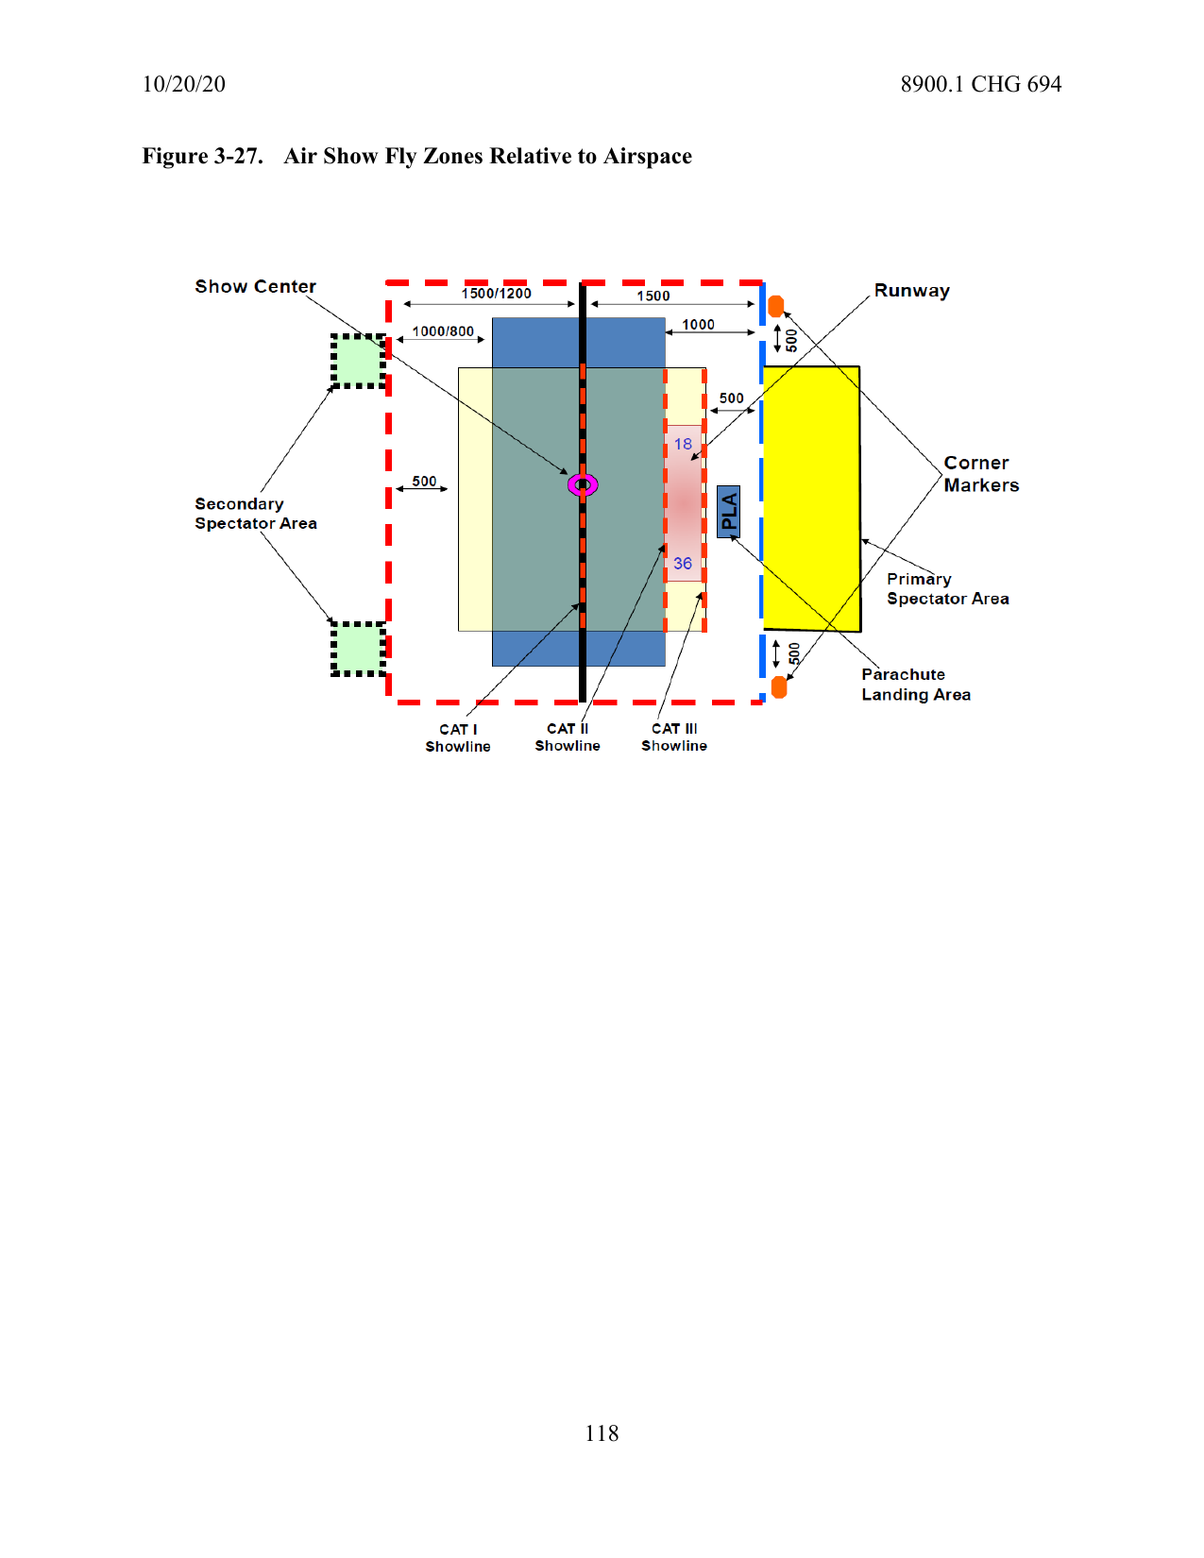
FAA Order 8900.1, Figure 3-27 — Air Show Fly Zones Relative to Airspace
Class D airports (most Basic Air Show sites): tower coordination required before and after the TFR window.
Class C sites require Approach Control coordination in addition to the tower.
Performers routing through adjacent MOAs or Restricted Areas require advance ATC/military coordination.
Air Show Demonstration Area (ASDA)
Figure 3-28 illustrates the ASDA — the full airspace volume encompassed by the COW. All aerial activity within the ASDA is under Air Boss authority during performance. At a Basic Air Show, Non-Participating Aircraft may not operate within the ASDA during performance.
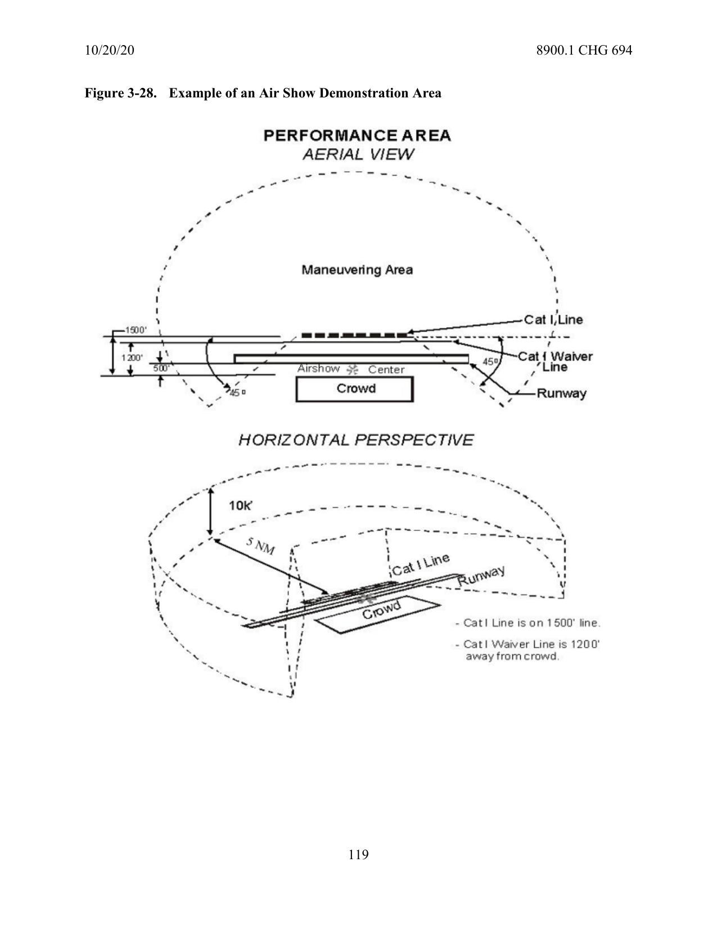
FAA Order 8900.1, Figure 3-28 — Example of an Air Show Demonstration Area
The ASDA outer boundary defines the extent of COW-waivered airspace.
The Flying Display Area (FDA) is the defined performance volume within the ASDA.
Air Boss authority over airspace ends at the ASDA boundary — ATC retains authority beyond it.
Typical Air Show Layout — ARFF Positioning
Figure 3-29 is the primary site layout diagram from 8900.1. It depicts the spatial relationships between the primary spectator area, crowd line, show line, aerobatic box, ARFF staging positions, and emergency access routes. This figure is directly referenced in site layout review requirements under FAA Order 8900.1.
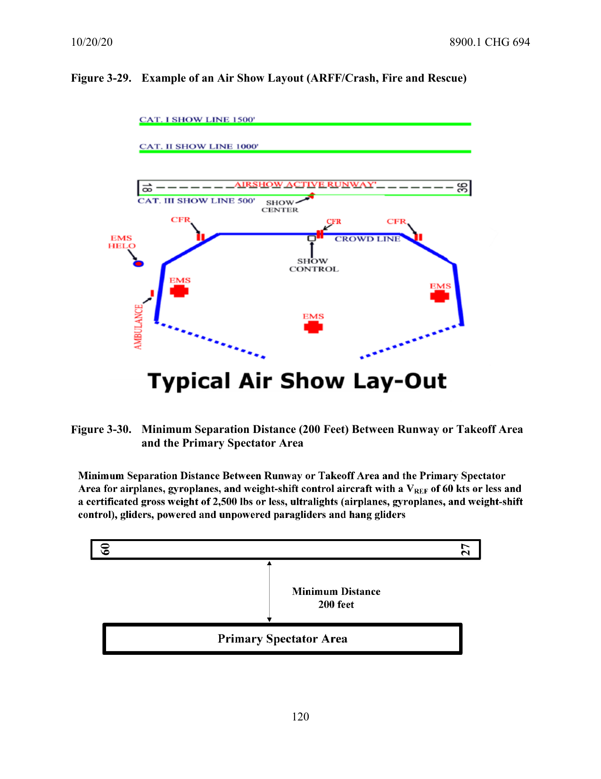
FAA Order 8900.1, Figure 3-29 — Example of an Air Show Layout (ARFF / Crash, Fire and Rescue)
ARFF must be able to reach any point in the aerobatic box within 1 minute of dispatch.
Emergency access routes must be identified and confirmed unobstructed before the first Show Day.
Corner markers of the aerobatic box must be highly visible landmarks or contrasting surface markings.
Show center is the reference point for all crowd-line separation distance measurements.

Category I Aircraft — Minimum Separation Distances
Category I aircraft are high-performance aerobatic aircraft with the most restrictive separation requirements. At a Basic Air Show, Cat I aerobatics are not authorized. However, Cat I non-aerobatic fly-bys are permitted and Figure 3-33 governs those operations.
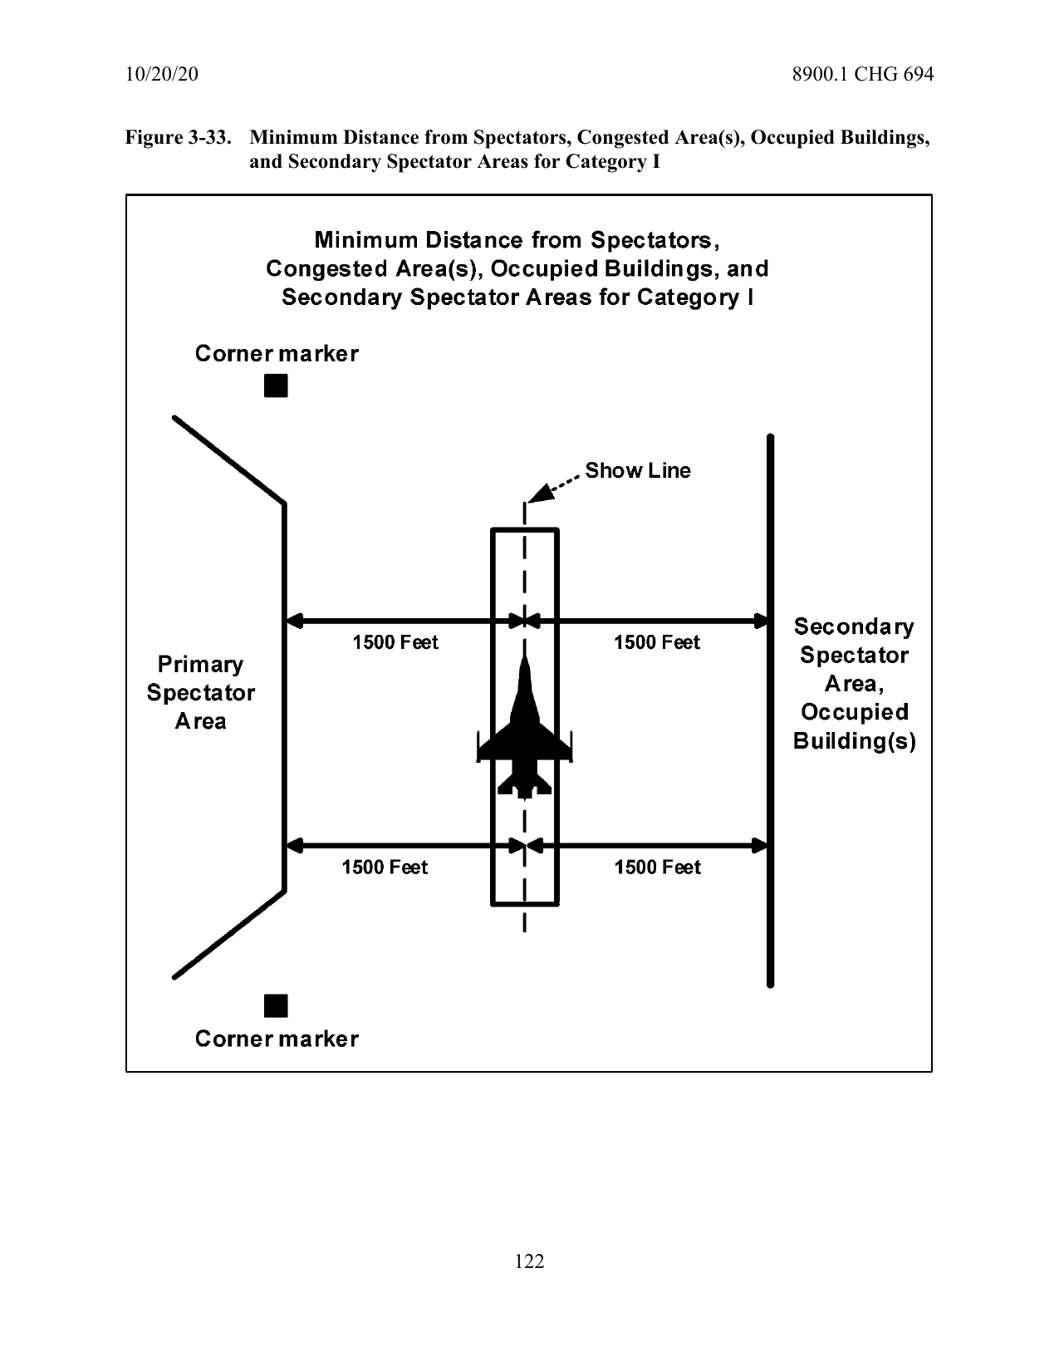
FAA Order 8900.1, Figure 3-33 — Minimum Distance from Spectators, Congested Area(s), Occupied Buildings, and Secondary Spectator Areas for Category I
Cat I aerobatics require an SAB or higher LOA — not within BAB authority.
Cat I non-aerobatic fly-bys are permitted at Basic Air Shows using these minimum distances.
All separation distances are measured from show center and are binding conditions of the COW.
Category I — Site Layout When FDA Is Less Than 1,500 Feet from Show Line
Figure 3-34 shows the more restrictive layout requirement when the Flying Display Area is positioned less than 1,500 feet from the show line. This situation requires additional planning and is most commonly encountered at constrained or non-standard sites.
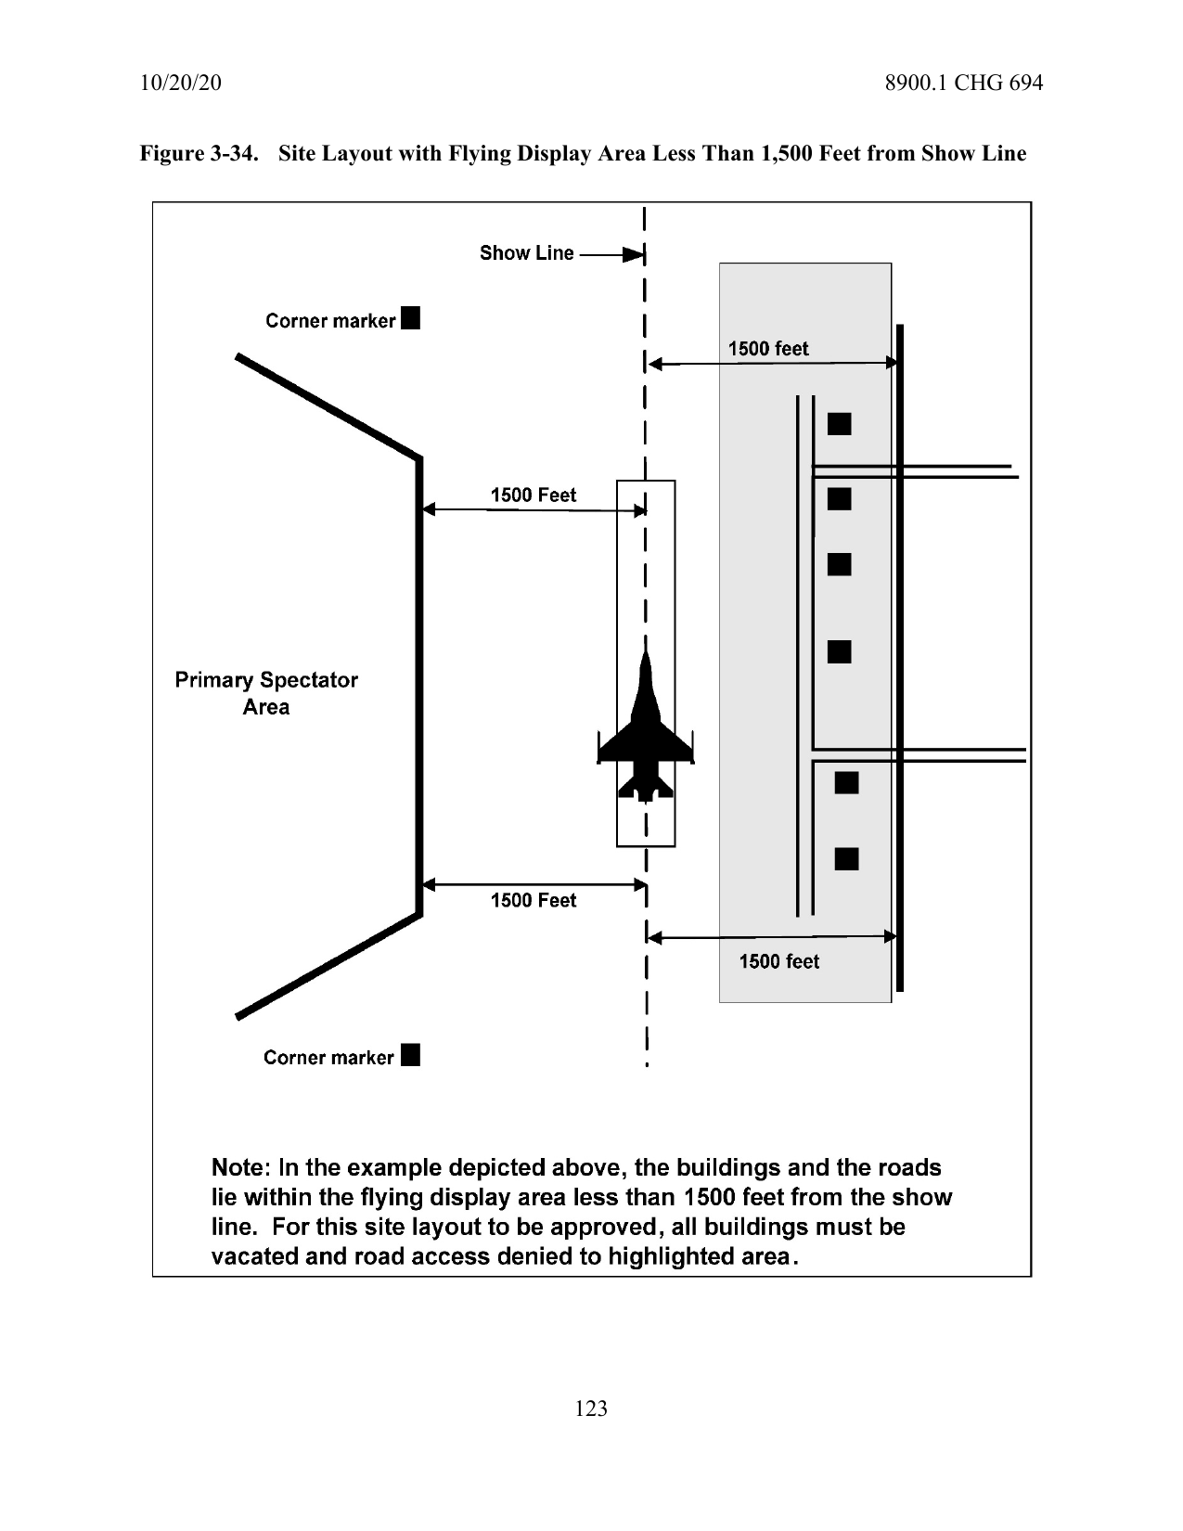
FAA Order 8900.1, Figure 3-34 — Site Layout with Flying Display Area Less Than 1,500 Feet from Show Line
When the FDA is less than 1,500 feet from the show line, additional COW provisions may apply.
The Air Boss must verify these constraints during site assessment and COW review.
This configuration is uncommon at Basic Air Shows — document and coordinate with the FSDO if encountered.
Category II Aircraft — Minimum Separation Distances
Category II aircraft — mid-performance aerobatic aircraft, formation teams, and warbirds performing aerobatics — are the primary category at most Basic Air Shows. Figure 3-36 defines the minimum separation distances that govern crowd line placement for these acts.
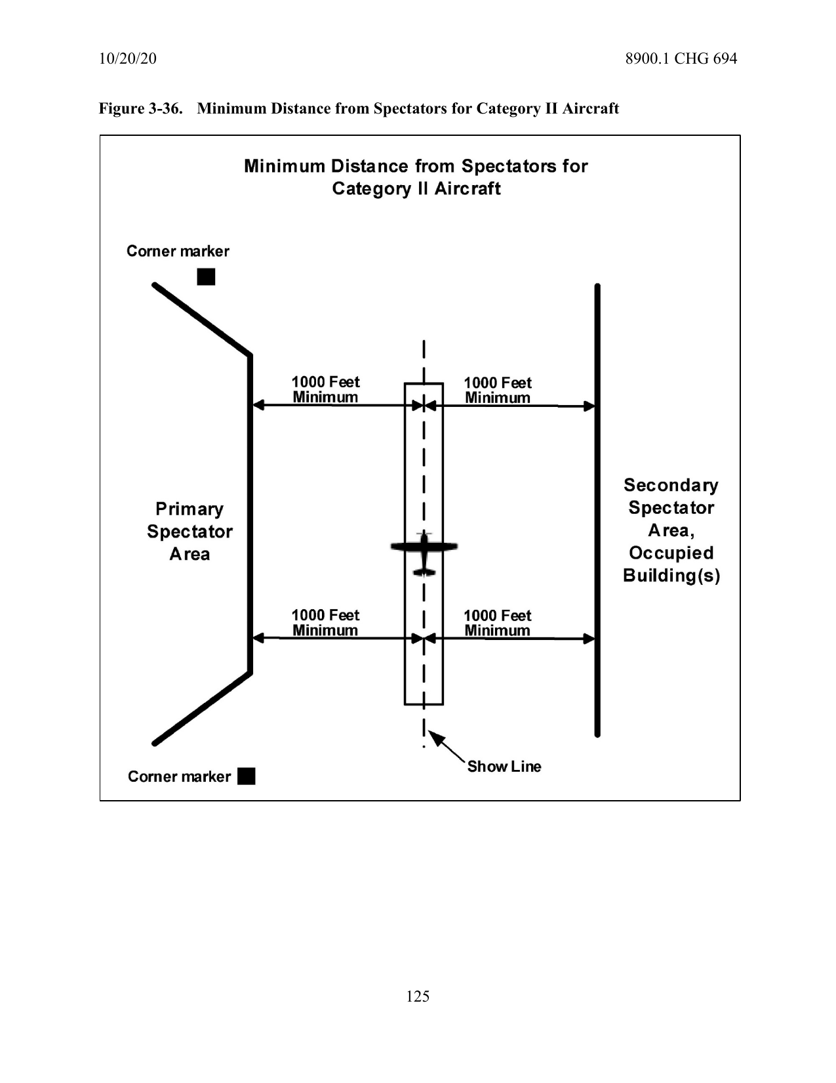
FAA Order 8900.1, Figure 3-36 — Minimum Distance from Spectators for Category II Aircraft
Cat II separation distances are specified in the COW's special provisions — verify against this figure.
Physical crowd line markers must be placed on the ground to enforce these distances.
The crowd line cannot be moved without a COW amendment — verify placement on the site walk.
Emergency vehicle access routes must not be obstructed by crowd line markers or spectators.

Category III Aircraft — Minimum Separation Distances
Category III aircraft perform fly-bys and non-aerobatic demonstrations. They carry the lowest separation requirements. Jump aircraft, military fly-bys, and static-performance aircraft typically operate in this category.
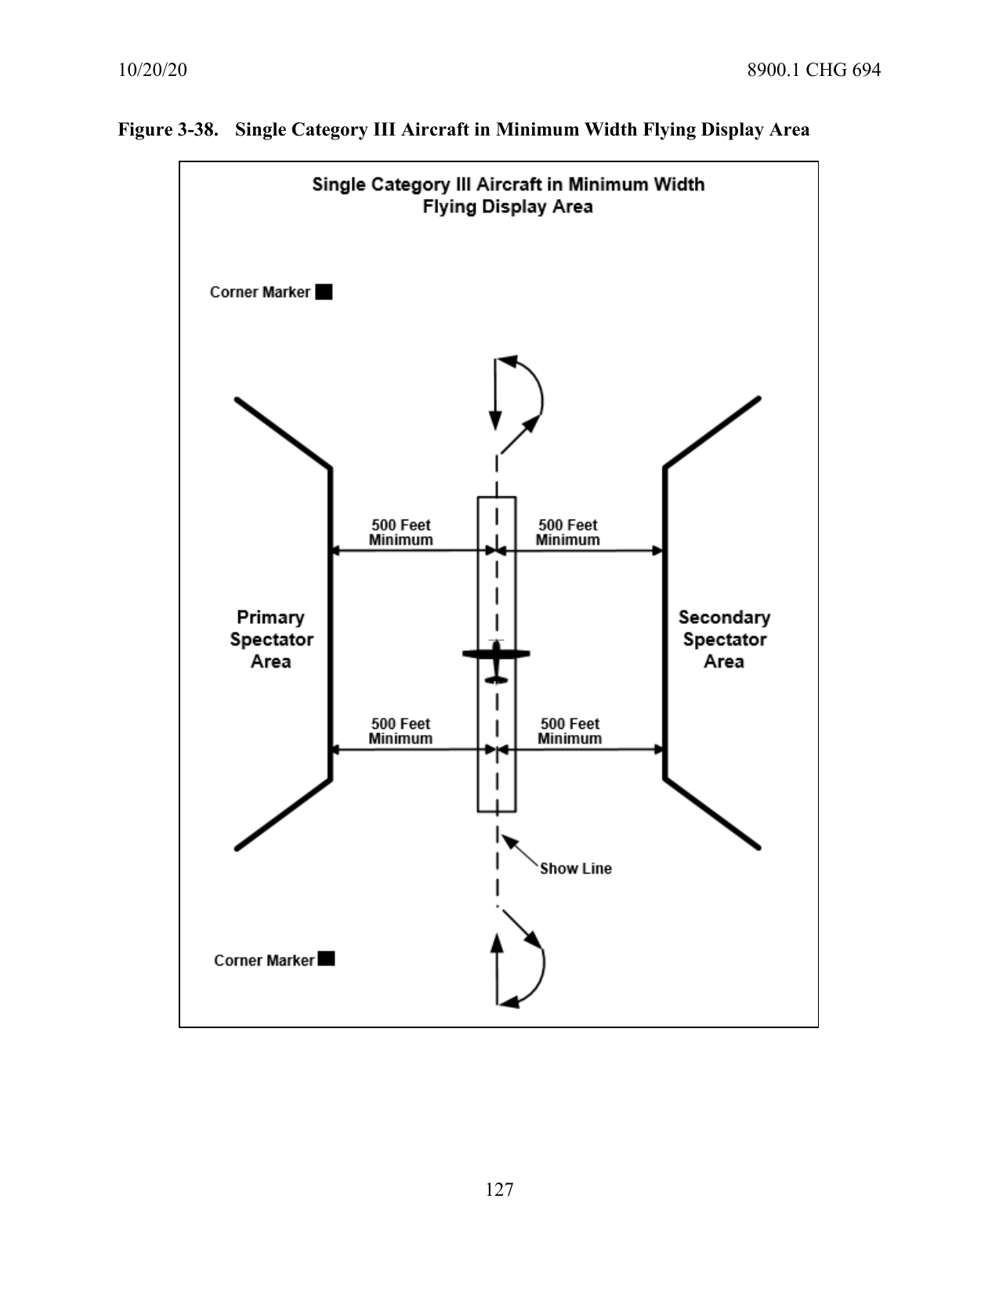
FAA Order 8900.1, Figure 3-38 — Single Category III Aircraft in Minimum Width Flying Display Area
Cat III includes: fly-bys, non-aerobatic passes, jump aircraft, and military single-ship non-aerobatic fly-bys.
Even at minimum separation, the crowd line must be marked and enforced.
Jump aircraft operating under the one-act-at-a-time rule count as the active act while jumpers are airborne.
No act closer than 500 feet from a spectator area — this floor applies regardless of category.

